EXCEL ASSIGNMENT 17

1. ***What are modules in VBA and describe in detail the importance of creating a module?***

***Ans.*** A module is the fundamental syntactic unit of VBA source code. The physical representation of a module is implementation dependent but logically a VBA module is a sequence of Unicode characters that conform to the VBA language grammars. A module consists of two parts: a module header and a module body.

*Importance of creating modules:-*

* **Write macros.**Macros allow financial professionals—whether accountants, commercial bankers, [investment bankers](https://www.investopedia.com/terms/i/investmentbanker.asp), research analysts, salesmen, traders, portfolio managers, clerks, or administrators—to analyze and adjust huge amounts of data quickly.
* **Update data.** You can use VBA in Excel to create and maintain complex trading, pricing, and risk-management models, forecast sales and earnings, and to generate [financial ratios](https://www.investopedia.com/financial-ratios-4689817).
* **Perform scenario-analysis.** With Visual Basic for Applications, you can create various portfolio-management and [investment scenarios](https://www.investopedia.com/terms/s/scenario_analysis.asp). This includes filtering through different situations that may impact outcomes differently.
* **Organize information.** You also may use VBA to produce lists of customers’ names or any other content; create invoices, forms, and charts; analyze scientific data, and manage data display for budgets and forecasting.
* **Be unconventional.** VBA can be used to copy and paste values, adjust cell styles for an entire workbook, and strike accelerator keys. You can perform very normal tasks but perform them in an easier, automated manner.
* **Prompt action.** VBA can be used to interact with users. For example, you may need a user's input for their first and last name to put on a form. VBA can be used to prompt a user in a way that makes this input unavoidably mandatory.

***2. What is Class Module and what is the difference between a Class***

***Module and a Module?***

***Ans.*** Comparison between Module and Class:

|  |  |  |
| --- | --- | --- |
|  | **Module** | **Class** |
| Inheritance | Not Supported | supported |
| Implement interfaces | No | Yes |
| Members | Shared (implicitly in Visual Basic) | Control the type of a member of a class as a shared or instance member |
| Object oriented | No, modules cannot be instantiated | Yes |
| Copy of the data | Only one copy | Object data exists separately for each instantiated object. |
| Typical application | Generally, used at the outer level for separating compilation, inner structures and privacy outside of the module boundaries | Generally as components of modules |
| Preferred | For abstract datatypes used with binary operations, such as sets with a merge operation | When inheritance is required |
| Members | Methods, constants and classes | Methods, constants and variables |
| Inclusion | Can be included by using include commands in classes or modules | Cannot be included |
| Super class | Object | Module |

1. ***What are Procedures? What is a Function Procedure and a Property Procedure?***

***Ans.*** A procedure is a block of Visual Basic statements enclosed by a declaration statement (Function, Sub, Operator, Get, Set) and a matching End declaration. All executable statements in Visual Basic must be within some procedure. Visual Basic uses several types of procedures:

* [Sub Procedures](https://learn.microsoft.com/en-us/dotnet/visual-basic/programming-guide/language-features/procedures/sub-procedures) perform actions but do not return a value to the calling code.
* Event-handling procedures are Sub procedures that execute in response to an event raised by user action or by an occurrence in a program.
* [Function Procedures](https://learn.microsoft.com/en-us/dotnet/visual-basic/programming-guide/language-features/procedures/function-procedures) return a value to the calling code. They can perform other actions before returning.

Some functions written in C# return a reference return value. Function callers can modify the return value, and this modification is reflected in the state of the called object. Starting with Visual Basic 2017, Visual Basic code can consume reference return values, although it cannot return a value by reference. For more information, see [Reference return values](https://learn.microsoft.com/en-us/dotnet/visual-basic/programming-guide/language-features/procedures/ref-return-values).

* [Property Procedures](https://learn.microsoft.com/en-us/dotnet/visual-basic/programming-guide/language-features/procedures/property-procedures) return and assign values of properties on objects or modules.
* [Operator Procedures](https://learn.microsoft.com/en-us/dotnet/visual-basic/programming-guide/language-features/procedures/operator-procedures) define the behavior of a standard operator when one or both of the operands is a newly-defined class or structure.
* [Generic Procedures in Visual Basic](https://learn.microsoft.com/en-us/dotnet/visual-basic/programming-guide/language-features/data-types/generic-procedures) define one or more type parameters in addition to their normal parameters, so the calling code can pass specific data types each time it makes a call.

*Function and property feature:-*

A property procedure is a series of Visual Basic statements that allow a programmer to create and manipulate custom properties. Property procedures can be used to create read-only properties for forms, standard modules, and class modules.

A Function procedure is a series of Visual Basic statements enclosed by the Function and End Function statements. The Function procedure performs a task and then returns control to the calling code. When it returns control, it also returns a value to the calling code.

1. ***What is a sub procedure and what are all the parts of a sub procedure and when are they used?***

***Ans.*** A Sub procedure is a series of Visual Basic statements enclosed by the Sub and End Sub statements. The Sub procedure performs a task and then returns control to the calling code, but it does not return a value to the calling code.

A sub procedure can take two forms, i.e., private and public. The modifiers “private” and “public” allows users to use the subs differently. The private sub procedure can only be used in the current module. The public sub allows users to use the procedure in all modules present in the workbook.

A sub-procedure in VBA can be defined as a procedure that executes a piece of code or instructions, but post-execution does not return the value of the tasks performed. A sub-procedure, therefore, does not require a variable for getting invoked. An excel VBA sub-routine or a sub-procedure is of executable nature and can be assigned as a macro to any excel based object. Like functions, they help in performing a set of repetitive tasks.

1. ***How do you add comments in a VBA code? How do you add multiple lines of comments in a VBA code?***

***Ans.*** The easiest way is to select all the lines and then use the comment button from the toolbar or you can also add an APOSTROPHE at the starting of each line.

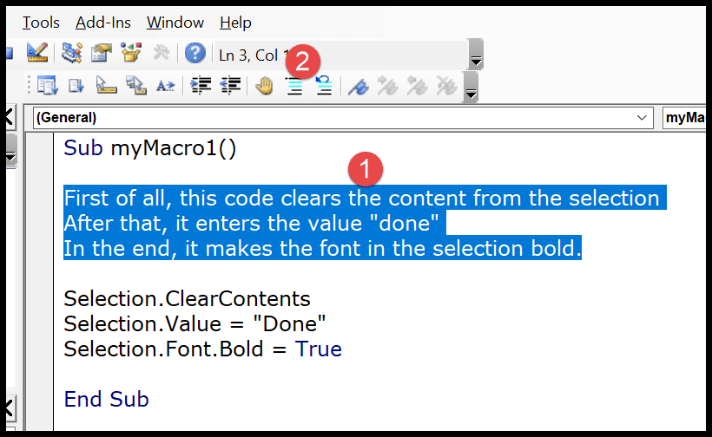

The moment you click the comment button it will convert all the lines into a multi-line comment block.

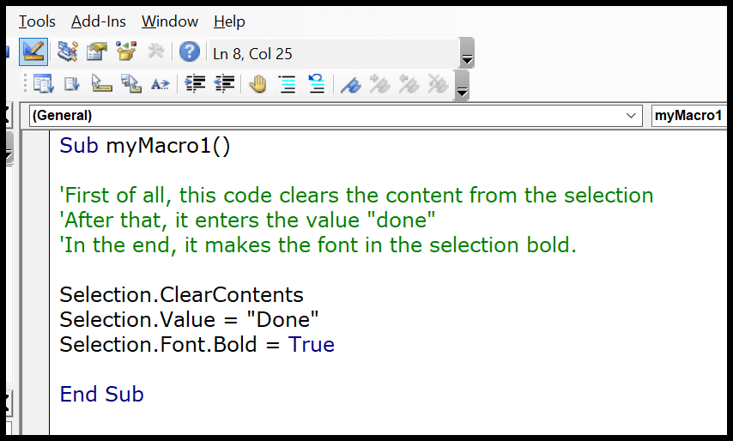

**Update:** There’s one thing that I have discovered recently if you have a block of comment line (continuous), you can use a line continuation character (an underscore must be immediately preceded by a space).

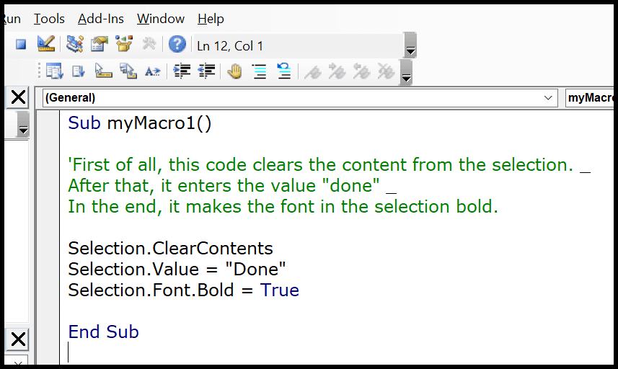

In the above example, I have used an apostrophe only at the start of the first line of the comment, the rest two-line don’t have an apostrophe but I have used line continuation character to give a line break at the end of the first line and the second line.

## Use the “REM” Keyword to Insert a Comment in VBA

This is the third way to insert a comment into a VBA code. Well, this is not a popular way but still, you can use it. So instead of using an apostrophe, you can use the **keyword REM** at the starting of a comment line.

REM stands for remarks.

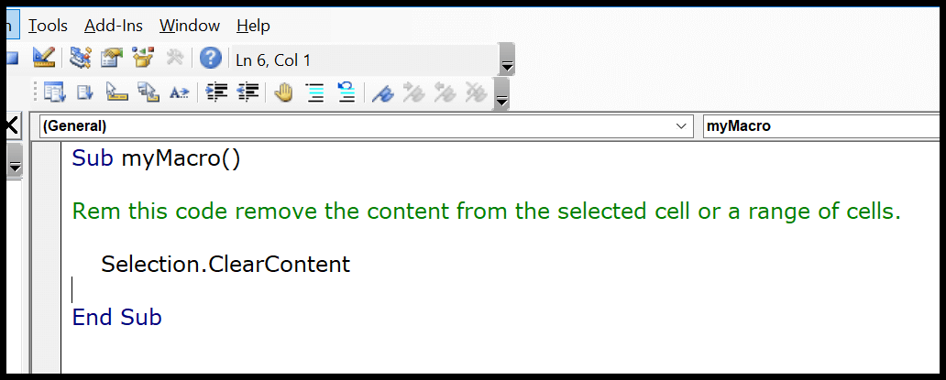

Now, in the above example, I have used “REM” at the start of the line of the code and then the line of the code. But, there’s no button to add REM, you have to type it.

## Comments while Recording a Macro with Macro Recorder

When you record a macro code using the macro recorder, you get an option to add a description before you record it.

So when you open the record macro dialog box, there is a “Description” input box where you can add your comment and then start recording.

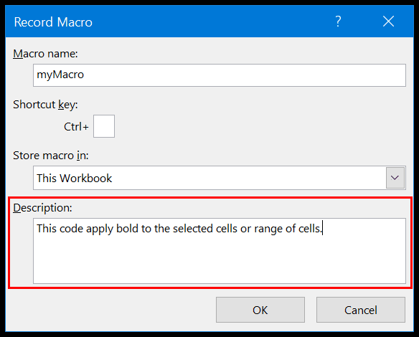

And when you open the VBE to see the recorded code, you can see the code which you have added as a comment. When you add a comment while recording a macro, VBA adds a few apostrophes as blank comments.

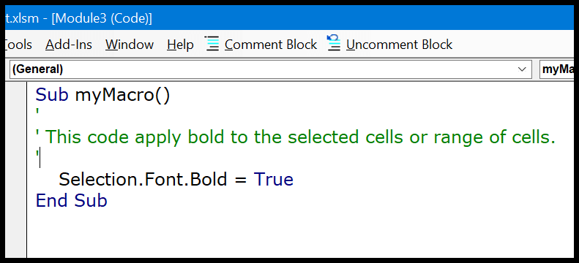

## Enter a Comment in the Same Line

This is a quite smart way to use a comment in the same line where you have written code. In the below example you can see that I have three lines of code, where I have added comments after each line to describe it.

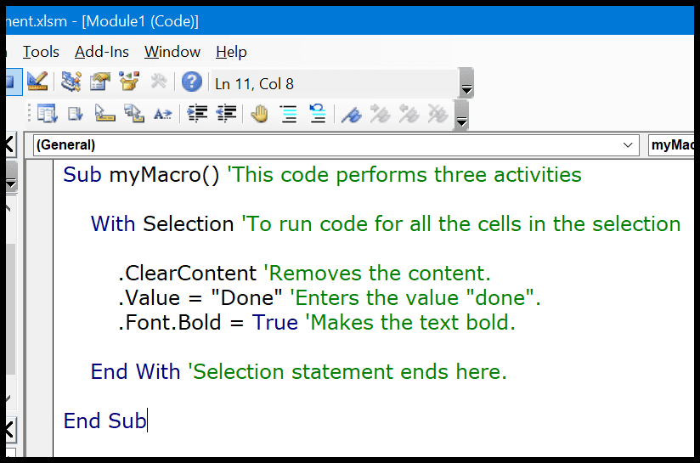

So once you complete a line of code you can use enter a comment after that in the same line.

## Shortcut Key for Add a Comment

* First of all, right-click on the toolbar and then click customize option.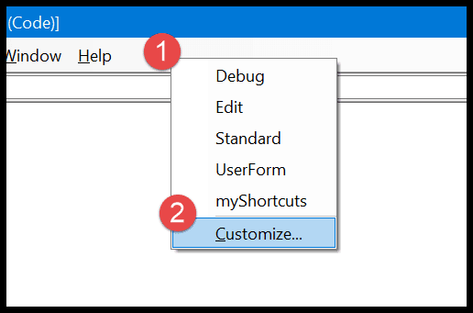
* In the customize dialog box, go to the Command-Tab ➜ Edit ➜ select the comment block, and drag it to the toolbar.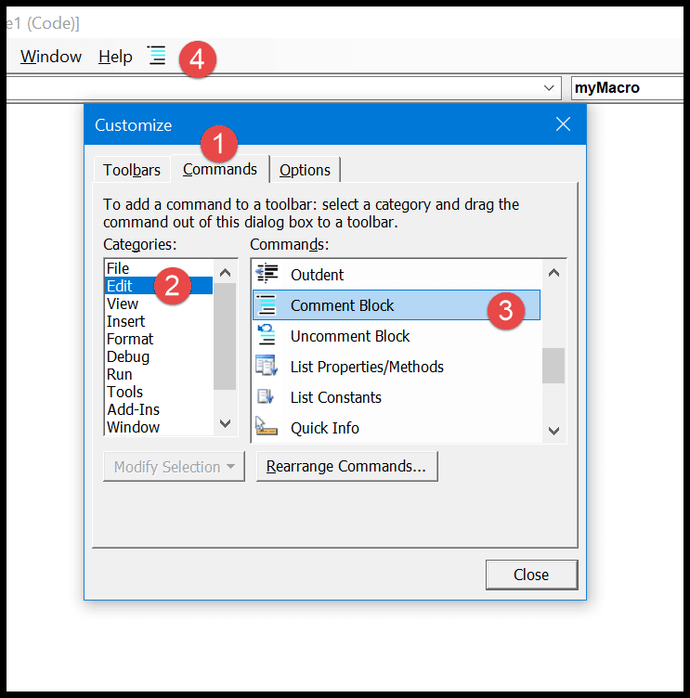
* After that select the comment block icon, like below and right-click on it, and then enter “&” before the name. So it should be like “&Comment Button”.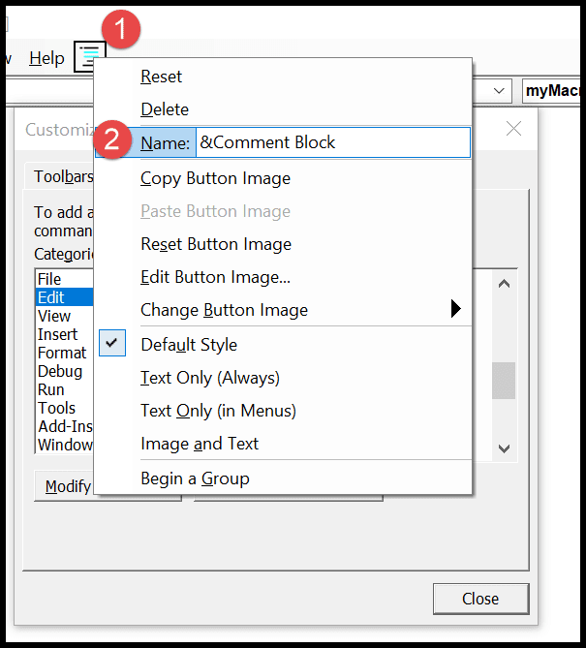
* Now, again right-click on the button and select the “Image and Text” and after that come back to the visual basic editor.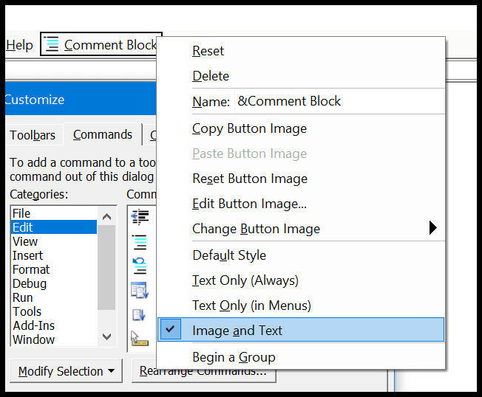

Now you can convert a line into a comment by using the **shortcut key Alt + C**.  And if you want to create a shortcut key for the uncomment button you can simply use the above steps to add the uncomment button to the toolbar and the shortcut key for it will be Alt + U.

## Change the Format of the Comment

VBA gives you an option to change the format of the comment if you want to do so. From the Tools ➜ Options ➜ Editor Format, click on the comment text.

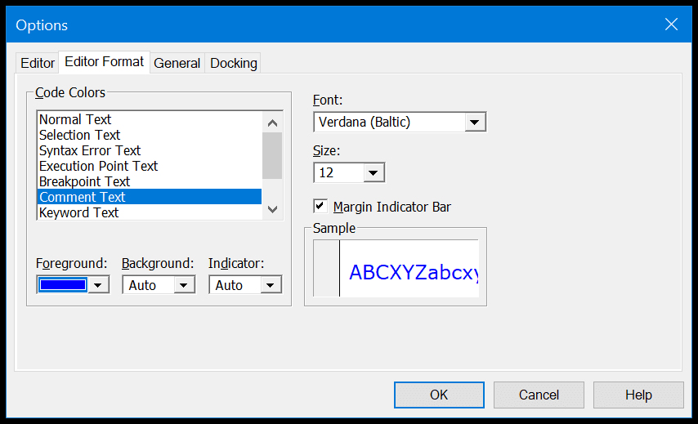

As you can see, I have changed the color of the comment text from green to blue. Now all the comments which I have in the code window are in blue color.